**1. Consume any REST API and load the response to database.**

**2. Implement SCD type 6 for the below “EMPLOYEE_Q2” table:**

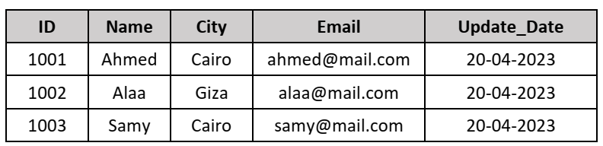

Notes:

1. The SCD fields are City and Email.

2. Read source data using Incremental Load.

**3. Load data to a table using versioning like below:**

3.1 Source table “EMPLOYEE_Q3”

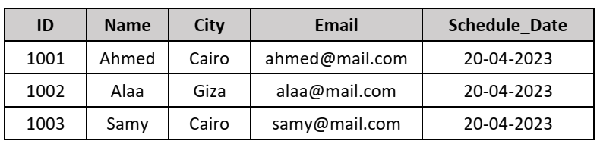

3.2 Target table after first run on the same day

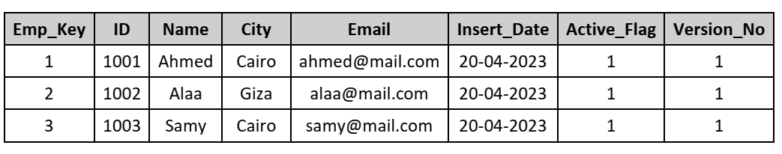

3.3 Target table after second run on the same day

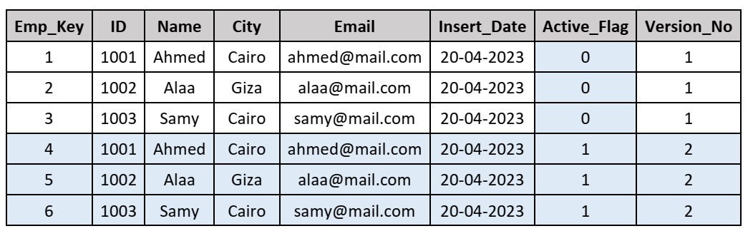

3.4 Target table after first run on the next day (just change Schedule_Datein the source data to simulate to next day)

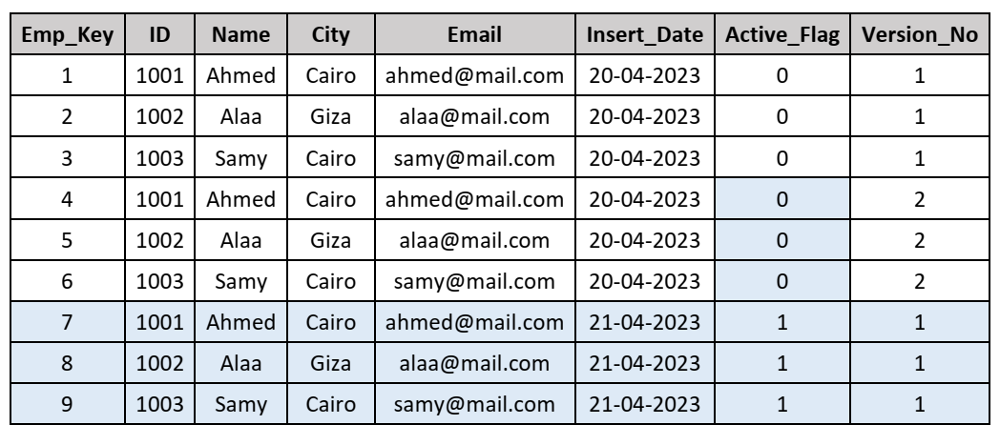

Notes:

1. Add new version as long as you are running on the same day and close all old

records.

2. Start from version 1 again on the next day and so on.

3. Don’t check for any change in the source data, load it as it is.